

DATABASES
October 2024 - February 2025

SCHOOL OF INFOCOMM TECHNOLOGY
Diploma in Information Technology
Diploma in Data Science

Databases Assignment – FINAL Report
(40% of DB Module)

06 Jan 2025 – 02 Feb 2025 (4 Weeks)

Deliverables | Deadline | Submission
Softcopy | Sunday 02 Feb 2025, 23:59 pm | BrightSpace Assignment  Final Submission link
Hardcopy | Monday 03 Feb 2025, 17:00 pm | Blk 31 Level 8 (Admin  Office),  Pigeon-holes (Databases)

DB Class Group |  | T10
Team Number |  | 3 | Team Grade:
Tutor |  | Ms Chong Kwee Leng
Members | Student No. | Student Name | Individual Grade
Members | 10267380F | Ashley Loh Yi Jie
Members | 10268927F | Chua Sing Yi Rachel
Members | 10267911K | Leong Hong Wei Dylan
Members | 10270460E | Teo Jin Rui
Members | 10266970K | Tiffany Loy Zhen Min

Penalty for late submission:
10% of the marks will be deducted for everyday (inclusive of Saturdays, Sundays, and Public Holidays) after the deadline.
NO submission will be accepted after 07 Feb 2025, 23:59 pm.
Table of Contents
DATABASES 1
SCHOOL OF INFOCOMM TECHNOLOGY 1
06 Jan 2025 – 02 Feb 2025 (4 Weeks) 1
MokeSell Relations (Logical Model) 3
Assumptions 4
Data Dictionary 5
Creating Database in SQL Server 12
Adding Data into Database 18
Table Contents 29
Individual Queries 40
Ashley 40
Rachel 42
Dylan 44
Jin Rui 46
Tiffany 48
Individual Contributions 50

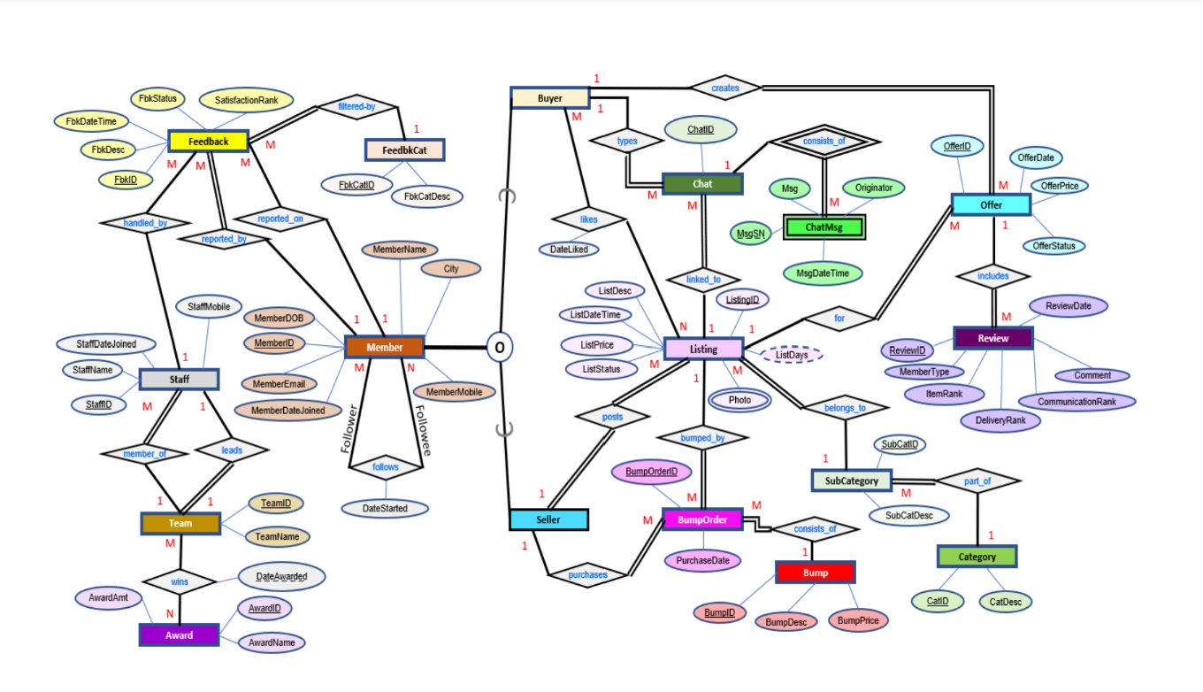

MokeSell Relations (Logical Model)
- Feedback (FbkID, FbkDesc, FbkDateTime, FbkStatus, SatisfactionRank, <FbkCatID>, <MemberID>, <StaffID>)
- FeedbkCat (FbkCatID, FbkCatDesc)
- Member (MemberID, MemberDOB, MemberEmail, MemberDateJoined, City, MemberMobile, MemberName)
- Follows (<FollowerID>, <FolloweeID>, DateStarted)
- Staff (StaffID, StaffName, StaffMobile, StaffDateJoined, <TeamID>)
- Team (TeamID, TeamName, <StaffID>)
- Award (AwardID, AwardName, AwardAmt, DateAwarded)
- Wins (<TeamID>, <AwardID>, DateAwarded)
- Seller (<SellerID>)
- Listing (ListingID, ListDesc, ListDateTime, ListPrice, ListStatus, <MemberID>, <SubCatID>)
- Photos(<ListingID>, Photo)
- Offer (OfferID, OfferDate, OfferPrice, OfferStatus, <ListingID>, <MemberID>)
- Review (ReviewID, ReviewDate, Comment, CommunicationRank, DeliveryRank, ItemRank, MemberType, <OfferID>)
- Buyer (<BuyerID>)
- Likes(<ListingID>, <MemberID>, DateLiked)
- Chat (ChatID, <MemberID>, <ListingID>)
- ChatMsg (<ChatID>, MsgSN, Msg, Originator, MsgDateTime)
- BumpOrder (BumpOrderID, PurchaseDate, <BumpID>, <ListingID>, <MemberID>)
- Bump (BumpID, BumpDesc, BumpPrice)
- SubCategory (<CatID>, SubCatID, SubCatDesc)
- Category (CatID, CatDesc)

Assumptions

- Feedback: OnMemberID has NULL values, as in certain cases, it doesn’t make sense for a member to be reported on.
- Member: City is NULL as some users may be uncomfortable sharing their location due to privacy concerns.
- Staff: Since it is not stated clearly whether MokeSell is operating in just Singapore, assume that it operated around the world, and set a constraint LENGTH(StaffMobile) BETWEEN 8 AND 15 as different countries have different number of digits for their phone number
- Award: Each team can win an award based on ratings provided by users. Ratings are based on the average overall rating over the years.
- Win: The awards are given out at the end of every year.
- Listings: All items sold on the platform are physical items and they all have a cost.
- Offer: Assume that OfferPrice is different from ListingPrice
- Review: Seller will rank DeliveryRank and ItemRank as NULL as they are not handling the delivery, and the item is their own item.

Data Dictionary

- Feedback Relation

Attribute Name | Description | Data Type and Length | Constraint | Null Value
FbkID | Unique identifier for each feedback | varchar(6) | Primary Key | No
FbkDesc | The description of the feedback | varchar(250) |  | No
FbkDateTime | The date and time the feedback was received | smalldatetime |  | No
  FbkDateTime not later than today
FbkStatus |  | varchar(20) | FbkStatus IN (‘Pending’,’Receiving Attention’,‘Completed’) | No
  Status of the feedback (e.g., Pending, Receiving Attention, Completed)
SatisfactionRank | Satisfaction rating for the feedback (1-5 Stars) | tinyint | SatisfactionRank  BETWEEN 1 AND 5 | No
FbkCatID |  | varchar(5) | Foreign Key --> FeedbkCat (FbkCatID) | No
  Identifier for the feedback category
OnMemberID |  | smallint | Foreign Key -->  Member (MemberID) | Yes
  Identifier for the member being reported on
ByMemberID |  | smallint | Foreign Key -->  Member (MemberID) | No
  Identifier for the member providing feedback
StaffID | Unique identifier for the Staff | varchar(4) | Foreign Key -->  Staff (StaffID) | No

- FeedbkCat Relation

Attribute Name | Description | Data Type and Length | Constraint | Null Value
FbkCatID | Unique identifier for the feedback category | varchar(5) | Primary Key | No
FbkCatDesc | Description of the feedback category (e.g. Technical Problem, Problem with another User, Problem with Listing, Suggestion) | varchar(100) |  | No

- Member Relation

Attribute Name | Description | Data Type and Length | Constraint | Null Value
MemberID | Unique identifier for each member | smallint | Primary Key | No
MemberName | Full name of the member | varchar(50) |  | No
MemberDOB | Date of birth of the member | smalldatetime | MemberDOB not later than today | No
MemberEmail | Email address of the member | varchar(100) |  | No
MemberMobile | Mobile number of the member | varchar(15) | Number of digits for MemberMobile between 8 and 15 | No
MemberDateJoined | Date the member joined MokeSell | smalldatetime | MemberDateJoined not later than today | No
City | The city of residence of the member | varchar(50) | Some members may not be comfortable sharing their location | Yes

- Follower Relation

Attribute Name | Description | Data Type and Length | Constraint | Null Value
MemberID | Unique identifier for the member being followed | smallint | Foreign Key --> Member (MemberID) | No
FollowerID | Unique identifier for the member following another | smallint | Foreign Key --> Member (MemberID) | No
DateStarted | The date when the following relationship started | smalldatetime | DateStarted not later than today | No

- Staff Relation

Attribute Name | Description | Data Type and Length | Constraint | Null Value
StaffID | Unique identifier for a staff member | varchar(4) | Primary Key | No
StaffName | Full name of the staff member | varchar(50) |  | No
StaffMobile | Mobile number of the staff member | varchar(15) | LENGTH(StaffMobile) BETWEEN 8 AND 15 | No
StaffDateJoined | Date the staff member joined MokeSell | smalldatetime | StaffDateJoined not later than today | No
TeamID | Unique identifier for the team the staff belongs to | varchar(4) | Foreign Key -->  Team (TeamID) | No

- Team Relation

Attribute Name | Description | Data Type and Length | Constraint | Null Value
TeamID | Unique identifier for the team the staff belongs to | varchar(4) | Primary Key | No
TeamName | Name of the team | varchar(30) |  | No
TeamLeaderID | Unique identifier of the team member that is the leader | varchar(4) | Foreign Key -->  Staff (StaffID) | Yes

- Award Relation

Attribute Name | Description | Data Type and Length | Constraint | Null Value
AwardID | Unique identifier for each award | varchar(4) | Primary Key | No
AwardName | Name of each award | varchar(30) |  | No
AwardAmt | Monetary value assigned to each award | smallmoney | Non-negative amount is awarded | No

- Win Relation

Attribute Name | Description | Data Type and Length | Constraint | Null Value
AwardID | Unique identifier of the award won | varchar(4) | Primary Key  Foreign Key -->  Award (AwardID) | No
TeamID | Unique identifier of the team that won the award | varchar(4) | Primary Key  Foreign Key -->  Team (TeamID) | No
DateAwarded | Date the award was given to the team | smalldatetime | Primary Key  DateAwarded not later than today | No

- Seller Relation

Attribute Name | Description | Data Type and Length | Constraint | Null Value
SellerID | Unique identifier for each seller | smallint | Primary Key  Foreign Key --> Member (MemberID) | No
- Likes Relation

Attribute Name | Description | Data Type and Length | Constraint | Null Value
BuyerID | Unique identifier for each buyer | smallint | Foreign Key -->  Buyer (BuyerID) | No
ListingID | Unique identifier for each listing | varchar(6) | Foreign Key -->  Listing (ListingID) | No
DateLiked | Date where listing is liked | smalldatetime | DateLiked not later than today | No

- Listing Relation

Attribute Name | Description | Data Type and Length | Constraint | Null Value
ListingID | Unique identifier for each listing | varchar(6) | Primary Key | No
ListDesc | Description of each listing | varchar(150) |  | No
ListDateTime | Date and time that the listing was created | smalldatetime | ListDateTime not later than today | No
ListPrice | Price set by a seller for their listed item | smallmoney | ListPrice not negative | No
ListStatus | Status of the listing | char(1) | Values: A for available, S for sold, I for inactive (after 30 days) | No
SellerID | Identifies the member that created the listing | smallint | Foreign key -->  Seller (SellerID) | No
SubCatID | Identifies the subcategories of the listing item | varchar(5) | Foreign key -->  SubCategory (SubCatID) | No

- ListingPhoto Relation

Attribute Name | Description | Data Type and Length | Constraint | Null Value
ListingID | Unique identifier for each listing | varchar(6) | Foreign key -->  Listing (ListingID) | No
Photo | Photo associated with each listing | varchar(50) |  | No

- Offer Relation

Attribute Name | Description | Data Type and Length | Constraint | Null Value
OfferID | Unique identifier for each offer | varchar(6) | Primary Key | No
BuyerID | Unique identifier for each buyer | smallint | Foreign Key -->  Buyer (BuyerID) | No
ListingID | Unique identifier for each listing | varchar(6) | Foreign Key -->  Listing (ListingID) | No
OfferPrice | Price offered by buyer for listing | smallmoney |  | No
OfferStatus | Status of offer made | char(1) | Values: P for pending, A for accepted, R for rejected | No
OfferDate | Date when offer was made | smalldatetime | OfferDate not later than today | No

- Review Relation

Attribute Name | Description | Data Type and Length | Constraint | Null Value
ReviewID | Unique identifier for each review | varchar(8) | Primary Key | No
ReviewDate | Date of the review | smalldatetime | ReviewDate not later than today | No
Comment | Additional comments by member | varchar(150) |  | Yes
CommunicationRank | Rating for any communication done between buyer and seller | tinyint | Check CommunicationRank BETWEEN 1 AND 5 | No
DeliveryRank | Rating for the delivery process of item | tinyint | Check DeliveryRank BETWEEN 1 AND 5 | Yes
ItemRank | Rating for the item | tinyint | Check ItemRank BETWEEN 1 AND 5 | Yes
MemberType | Type of member who submitted the review | char(1) | Values: S for seller, B for buyer | No
OfferID | Identifies the offer that the review is made for | varchar(6) | Foreign key -->  Offer (OfferID) | No

- Buyer Relation

Attribute Name | Description | Data Type and Length | Constraint | Null Value
BuyerID | Unique identifier for each buyer | smallint | Primary Key  Foreign Key -->  Member (MemberID) | No

- Chat Relation

Attribute Name | Description | Data Type and Length | Constraint | Null Value
ChatID | Unique identifier for each chat | varchar(6) | Primary Key | No
BuyerID | Unique identifier for each buyer | smallint | Foreign Key -->  Buyer (BuyerID) | No
ListingID | Unique identifier for each listing | varchar(6) | Foreign Key -->  Listing (ListingID) | No

- ChatMsg Relation

Attribute Name | Description | Data Type and Length | Constraint | Null Value
ChatID | Unique identifier for each chat | varchar(6) | Foreign Key -->  Chat (ChatID) | No
MsgSN | Message sequence number | char(3) |  | No
MsgDateTime | Time when message is sent | smalldatetime | MsgDateTime not later than today | No
Originator | Original sender of message | char(1) | Values: S for seller, B for buyer | No
Msg | Content of message | varchar(250) |  | Yes

- Category Relation

Attribute Name | Description | Data Type and Length | Constraint | Null Value
CatID | Unique identifier for each listing category | varchar(3) | Primary Key | No
CatDesc | The description of the category | varchar(30) |  | No

- SubCategory Relation

Attribute Name | Description | Data Type and Length | Constraint | Null Value
SubCatID | Unique identifier for each subcategory of a listing category | varchar(5) | Primary Key | No
SubCatDesc | The description of the subcategory of a listing category | varchar(50) |  | No
CatID | The category that the subcategory is part of | varchar(3) | Foreign Key -->  Category (CatID) | No

- Bump Relation

Attribute Name | Description | Data Type and Length | Constraint | Null Value
BumpID | Unique identifier for each type of bump | varchar(2) | Primary Key  Values: O for one time bump, D3 for 3 daily bumps, T3 for 3 twice a day bumps, D7 for 7 daily bumps. | No
BumpDesc | The description of the bump | varchar(50) |  | No
BumpPrice | The price of the bump | smallmoney |  | No

- Bump Order Relation

Attribute Name | Description | Data Type and Length | Constraint | Null Value
BumpOrderID | Unique identifier for each bump order | varchar(6) | Primary Key | No
PurchaseDate | The date when a seller purchases a bump | smalldatetime | PurchaseDate not later than today | No
BumpID | The type of bump purchased for the order | varchar(2) | Foreign Key -->  Bump (BumpID) | No
ListingID | The listing that was bumped | varchar(6) | Foreign Key -->  Listing (ListingID) | No
SellerID | The seller who made the bump order | smallint | Foreign Key -->  Seller (SellerID) | No

Creating Database in SQL Server

-- Create MokeSell Database
CREATE DATABASE MokeSell;
GO

USE MokeSell;
GO

-- Category Relation
CREATE TABLE Category
(
CatID varchar(3) NOT NULL,
CatDesc varchar(30) NOT NULL,

-- Constraints
CONSTRAINT PK_Category PRIMARY KEY (CatID)
);

-- SubCategory Relation
CREATE TABLE SubCategory
(
SubCatID varchar(5) NOT NULL,
SubCatDesc varchar(50) NOT NULL,
CatID varchar(3) NOT NULL,

-- Constraints
CONSTRAINT PK_SubCategory PRIMARY KEY (SubCatID),
CONSTRAINT FK_SubCategory_CatID FOREIGN KEY (CatID) REFERENCES Category(CatID)
);

-- Member Relation
CREATE TABLE Member
(
MemberID smallint NOT NULL,
MemberName varchar(50) NOT NULL,
MemberDOB smalldatetime NOT NULL CHECK (MemberDOB <= GETDATE()),
MemberEmail varchar(100) NOT NULL,
MemberMobile varchar(15) NOT NULL CHECK (LEN(MemberMobile) BETWEEN 8 AND 15),
MemberDateJoined smalldatetime NOT NULL CHECK (MemberDateJoined <= GETDATE()),
City varchar(50),

-- Constraints
CONSTRAINT PK_Member PRIMARY KEY (MemberID)
);

-- Follower Relation
CREATE TABLE Follower
(
MemberID smallint NOT NULL,
FollowerID smallint NOT NULL,
DateStarted smalldatetime NOT NULL CHECK (DateStarted <= GETDATE()),

-- Constraints
CONSTRAINT PK_Follower PRIMARY KEY (MemberID, FollowerID),
CONSTRAINT FK_Follower_MemberID FOREIGN KEY (MemberID) REFERENCES Member(MemberID),
CONSTRAINT FK_Follower_FollowerID FOREIGN KEY (FollowerID) REFERENCES Member(MemberID)
);

-- Buyer Relation
CREATE TABLE Buyer
(
BuyerID smallint NOT NULL,

-- Constraints
CONSTRAINT PK_Buyer PRIMARY KEY (BuyerID),
CONSTRAINT FK_Buyer_BuyerID FOREIGN KEY (BuyerID) REFERENCES Member (MemberID)
);

-- Seller Relation
CREATE TABLE Seller
(
SellerID smallint NOT NULL,

-- Constraints
CONSTRAINT PK_Seller PRIMARY KEY (SellerID),
CONSTRAINT FK_Seller_SellerID FOREIGN KEY (SellerID) REFERENCES Member(MemberID)
);

-- Listing Relation
CREATE TABLE Listing
(
ListingID varchar(6) NOT NULL,
ListDesc varchar(150) NOT NULL,
ListDateTime smalldatetime NOT NULL CHECK (ListDateTime <= GETDATE()) ,
ListPrice smallmoney NOT NULL CHECK (ListPrice >= 0),
ListStatus char(1) NOT NULL CHECK (ListStatus IN ('A', 'S', 'I')),
SellerID smallint NOT NULL,
SubCatID varchar(5) NOT NULL,

-- Constraints
CONSTRAINT PK_Listing PRIMARY KEY (ListingID),
CONSTRAINT FK_Listing_SellerID FOREIGN KEY (SellerID) REFERENCES Seller(SellerID),
CONSTRAINT FK_Listing_SubCatID FOREIGN KEY (SubCatID) REFERENCES SubCategory(SubCatID)
);

-- ListingPhoto Relation
CREATE TABLE ListingPhoto
(
ListingID varchar(6) NOT NULL,
Photo varchar(50) NOT NULL,

-- Constraints
CONSTRAINT PK_ListingPhoto PRIMARY KEY (ListingID, Photo),
CONSTRAINT FK_ListingPhoto_ListingID FOREIGN KEY (ListingID) REFERENCES Listing(ListingID)
);

-- Likes Relation
CREATE TABLE Likes
(
BuyerID smallint NOT NULL,
ListingID varchar(6) NOT NULL,
DateLiked smalldatetime NOT NULL CHECK (DateLiked <= GETDATE()),

-- Constraints
CONSTRAINT PK_Likes PRIMARY KEY (BuyerID, ListingID),
CONSTRAINT FK_Likes_BuyerID FOREIGN KEY (BuyerID) REFERENCES Buyer (BuyerID),
CONSTRAINT FK_Likes_ListingID FOREIGN KEY (ListingID) REFERENCES Listing (ListingID)
);

-- Offer Relation
CREATE TABLE Offer
(
OfferID varchar(6) NOT NULL,
BuyerID smallint NOT NULL,
ListingID varchar(6) NOT NULL,
OfferPrice smallmoney NOT NULL,
OfferStatus char(1) NOT NULL CHECK (OfferStatus IN ('P', 'A' , 'R')),
OfferDate smalldatetime NOT NULL CHECK (OfferDate <= GETDATE()),

-- Constraints
CONSTRAINT PK_Offer PRIMARY KEY (OfferID),
CONSTRAINT FK_Offer_BuyerID FOREIGN KEY (BuyerID) REFERENCES Buyer (BuyerID),
CONSTRAINT FK_Offer_ListingID FOREIGN KEY (ListingID) REFERENCES Listing (ListingID)
);

-- Review Relation
CREATE TABLE Review
(
ReviewID varchar(8) NOT NULL,
ReviewDate smalldatetime NOT NULL CHECK (ReviewDate <= GETDATE()),
Comment varchar(150),
CommunicationRank tinyint NOT NULL CHECK (CommunicationRank BETWEEN 1 AND 5),
DeliveryRank tinyint CHECK (DeliveryRank BETWEEN 1 AND 5),
ItemRank tinyint CHECK (ItemRank BETWEEN 1 AND 5),
MemberType char(1) NOT NULL CHECK (MemberType IN ('S', 'B')),
OfferID varchar(6) NOT NULL,

-- Constraints
CONSTRAINT PK_Review PRIMARY KEY (ReviewID),
CONSTRAINT FK_Review_OfferID FOREIGN KEY (OfferID) REFERENCES Offer(OfferID)
);

-- Team Relation
CREATE TABLE Team
(
TeamID varchar(4) NOT NULL,
TeamName varchar(30) NOT NULL,
TeamLeaderID varchar(4),

-- Constraints
CONSTRAINT PK_Team PRIMARY KEY (TeamID),
);

-- Staff Relation
CREATE TABLE Staff
(
StaffID varchar(4) NOT NULL,
StaffName varchar(50) NOT NULL,
StaffMobile varchar(15) NOT NULL CHECK (LEN(StaffMobile) BETWEEN 8 AND 15),
StaffDateJoined smalldatetime NOT NULL CHECK (StaffDateJoined <= GETDATE()),
TeamID varchar(4) NOT NULL,

-- Constraints
CONSTRAINT PK_Staff PRIMARY KEY (StaffID),
);

-- Add FK to Team Table for TeamLeaderID --
ALTER TABLE Team
ADD CONSTRAINT FK_Team_TeamLeaderID FOREIGN KEY (TeamLeaderID) REFERENCES Staff(StaffID);

-- Add FK to Staff Table for TeamID --
ALTER TABLE Staff
ADD CONSTRAINT FK_Staff_TeamID FOREIGN KEY (TeamID) REFERENCES Team(TeamID);

-- Award Relation
CREATE TABLE Award
(
AwardID varchar(4) NOT NULL,
AwardName varchar(30) NOT NULL,
AwardAmt smallmoney NOT NULL CHECK (AwardAmt >= 0)

-- Constraints
CONSTRAINT PK_Award PRIMARY KEY (AwardID)
);

-- Win Relation
CREATE TABLE Win
(
AwardID varchar(4) NOT NULL,
TeamID varchar(4) NOT NULL,
DateAwarded smalldatetime NOT NULL CHECK (DateAwarded <= GETDATE()),

-- Constraints
CONSTRAINT PK_Win PRIMARY KEY (AwardID, TeamID, DateAwarded),
CONSTRAINT FK_Win_AwardID FOREIGN KEY (AwardID) REFERENCES Award(AwardID),
CONSTRAINT FK_Win_TeamID FOREIGN KEY (TeamID) REFERENCES Team(TeamID)
);

-- FeedbkCat Relation
CREATE TABLE FeedbkCat
(
FbkCatID varchar(5) NOT NULL,
FbkCatDesc varchar(100) NOT NULL,

-- Constraints
CONSTRAINT PK_FeedbkCat PRIMARY KEY (FbkCatID)
);

-- Feedback Relation
CREATE TABLE Feedback
(
FbkID varchar(6) NOT NULL,
FbkDesc varchar(250) NOT NULL,
FbkDateTime smalldatetime NOT NULL CHECK (FbkDateTime <= GETDATE()),
FbkStatus varchar(20) NOT NULL CHECK (FbkStatus IN ('Pending', 'Receiving Attention', 'Completed')),
SatisfactionRank tinyint NOT NULL CHECK (SatisfactionRank BETWEEN 1 AND 5),
FbkCatID varchar(5) NOT NULL,
OnMemberID smallint,
ByMemberID smallint NOT NULL,
StaffID varchar(4) NOT NULL,

-- Constraints
CONSTRAINT PK_Feedback PRIMARY KEY (FbkID),
CONSTRAINT FK_Feedback_FbkCatID FOREIGN KEY (FbkCatID) REFERENCES FeedbkCat(FbkCatID),
CONSTRAINT FK_Feedback_OnMember FOREIGN KEY (OnMemberID) REFERENCES Member(MemberID),
CONSTRAINT FK_Feedback_ByMember FOREIGN KEY (ByMemberID) REFERENCES Member(MemberID),
CONSTRAINT FK_Feedback_Staff FOREIGN KEY (StaffID) REFERENCES Staff(StaffID)
);
-- Bump Relation
Create TABLE Bump
(
BumpID varchar(2) NOT NULL CHECK(BumpID in ('O','D3','T3','D7')),
BumpDesc varchar(50) NOT NULL,
BumpPrice smallmoney NOT NULL,

--Constraints
CONSTRAINT PK_Bump PRIMARY KEY (BumpID)
);

-- BumpOrder Relation
Create TABLE BumpOrder
(
BumpOrderID varchar(6) NOT NULL,
PurchaseDate smalldatetime NOT NULL CHECK(PurchaseDate <= GETDATE()),
BumpID varchar(2) NOT NULL,
ListingID varchar(6) NOT NULL,
SellerID smallint NOT NULL,

--Constraints
CONSTRAINT PK_BumpOrder PRIMARY KEY (BumpOrderID),
CONSTRAINT FK_BumpOrder_BumpID FOREIGN KEY (BumpID) REFERENCES Bump(BumpID),
CONSTRAINT FK_BumpOrder_Listing_ListingID FOREIGN KEY (ListingID) REFERENCES Listing(ListingID),
CONSTRAINT FK_BumperOrder_SellerID FOREIGN KEY (SellerID) REFERENCES Seller(SellerID)
);

-- Chat Relation
CREATE TABLE Chat
(
ChatID varchar(6) NOT NULL,
BuyerID smallint NOT NULL,
ListingID varchar(6) NOT NULL,

-- Constraints
CONSTRAINT PK_Chat PRIMARY KEY (ChatID),
CONSTRAINT FK_Chat_BuyerID FOREIGN KEY (BuyerID) REFERENCES Buyer (BuyerID),
CONSTRAINT FK_Chat_ListingID FOREIGN KEY (ListingID) REFERENCES Listing (ListingID)
);

-- ChatMsg Relation
CREATE TABLE ChatMsg
(
ChatID varchar(6) NOT NULL,
MsgSN char(3) NOT NULL,
MsgDateTime smalldatetime NOT NULL CHECK (MsgDateTime <= GETDATE()),
Originator char(1) NOT NULL CHECK (Originator IN ('S', 'B')),
Msg varchar(250),

-- Constraints
CONSTRAINT PK_ChatMsg PRIMARY KEY (ChatID, MsgSN),
CONSTRAINT FK_ChatMsg_ChatID FOREIGN KEY (ChatID) REFERENCES Chat (ChatID)
);

Adding Data into Database

-- Category Relation Data
INSERT INTO Category (CatID, CatDesc)
VALUES
('C01','Product Condition'),
('C02','Product Category'),
('C03','Collection Method'),
('C04','Payment Type'),
('C05','Listing Status');

-- SubCategory Relation Data
INSERT INTO SubCategory (SubCatID, SubCatDesc, CatID)
VALUES
('SC001','New','C01'),
('SC002','Used','C01'),
('SC003','Refurbished','C01'),
('SC004','Like New','C01'),
('SC005','Electronics','C02'),
('SC006','Clothing & Accessories','C02'),
('SC007','Home & Living','C02'),
('SC008','Sports & Outdoors','C02'),
('SC009','Books & Media','C02'),
('SC010','Toys & Games','C02'),
('SC011','Meet Up','C03'),
('SC012','Mailing','C03'),
('SC013','Pick Up','C03'),
('SC014','Cash On Delivery','C04'),
('SC015','Bank Transfer','C04'),
('SC016','New Listing','C05'),
('SC017','Bump Once','C05'),
('SC018','Bump Daily','C05'),
('SC019','Bump Twice A Day','C05');

-- Member Relation Data
INSERT INTO Member (MemberID, MemberName, MemberDOB, MemberEmail, MemberMobile, MemberDateJoined, City)
VALUES
('00001', 'John Doe', '1990-01-15', 'john.doe@gmail.com', '1234567890', '2023-01-10', 'New York'),
('00002', 'Jane Smith', '1985-03-20', 'jane.smith@ymail.com', '9876543210', '2022-05-15', 'Los Angeles'),
('00003', 'Michael Brown', '1992-07-11', 'michael.brown@hotmail.com', '1231231234', '2021-09-01', 'Chicago'),
('00004', 'Emily Davis', '1998-12-05', 'emily.davis@outlook.com', '4564564567', '2020-11-25', NULL),
('00005', 'Chris Wilson', '1995-04-18', 'chris.wilson@gmail.com', '7897897890', '2023-04-10', 'Houston'),
('00006', 'Sophia Johnson', '2000-08-21', 'sophia.johnson@ymail.com', '9876541230', '2023-07-20', 'Phoenix'),
('00007', 'David Garcia', '1994-09-30', 'david.garcia@hotmail.com', '1230984567', '2022-01-15', 'Philadelphia'),
('00008', 'Mia Martinez', '1988-11-14', 'mia.martinez@outlook.com', '7894561230', '2021-12-01', NULL),
('00009', 'James Anderson', '1982-06-23', 'james.anderson@gmail.com', '4567891234', '2020-08-10', 'San Antonio'),
('00010', 'Olivia Thompson', '1993-05-12', 'olivia.thompson@ymail.com', '3216549870', '2023-06-14', 'San Diego'),
('00011', 'Daniel Lee', '1996-02-27', 'daniel.lee@hotmail.com', '1472583690', '2023-02-15', 'Dallas'),
('00012', 'Isabella Harris', '1989-10-10', 'isabella.harris@outlook.com', '7891234560', '2021-05-20', 'Austin'),
('00013', 'Ethan Clark', '1991-01-07', 'ethan.clark@gmail.com', '2581473690', '2022-04-30', 'Jacksonville'),
('00014', 'Ava Lewis', '1997-03-25', 'ava.lewis@ymail.com', '1237894560', '2023-08-01', 'San Francisco'),
('00015', 'Alexander Young', '1984-12-18', 'alexander.young@hotmail.com', '4561237890', '2020-07-05', 'Indianapolis'),
('00016', 'Charlotte King', '1999-07-19', 'charlotte.king@outlook.com', '7896543210', '2023-03-22', 'Seattle'),
('00017', 'Henry Wright', '1987-08-03', 'henry.wright@gmail.com', '3217896540', '2021-10-30', NULL),
('00018', 'Amelia Scott', '1990-05-09', 'amelia.scott@ymail.com', '6549873210', '2022-12-11', 'Denver'),
('00019', 'Lucas Hall', '1993-09-28', 'lucas.hall@hotmail.com', '7893216540', '2023-01-18', 'Washington'),
('00020', 'Lily Allen', '1992-04-13', 'lily.allen@outlook.com', '1236547890', '2020-03-05', 'Boston');

-- Follower Relation Data
INSERT INTO Follower
VALUES
('00001', '00002', '2023-01-01 10:00:00'),
('00003', '00004', '2023-02-15 11:30:00'),
('00005', '00006', '2023-03-12 09:15:00'),
('00007', '00008', '2023-04-25 14:00:00'),
('00009', '00010', '2023-05-05 16:45:00'),
('00011', '00012', '2023-06-20 18:20:00'),
('00013', '00014', '2023-07-10 08:00:00'),
('00015', '00016', '2023-08-30 12:10:00'),
('00017', '00018', '2023-09-14 13:30:00'),
('00019', '00020', '2023-10-01 15:45:00'),
('00002', '00003', '2023-01-01 10:00:00'),
('00004', '00005', '2023-02-15 11:30:00'),
('00006', '00007', '2023-03-12 09:15:00'),
('00008', '00009', '2023-04-25 14:00:00'),
('00010', '00011', '2023-05-05 16:45:00'),
('00012', '00013', '2023-06-20 18:20:00'),
('00014', '00015', '2023-07-10 08:00:00'),
('00016', '00017', '2023-08-30 12:10:00'),
('00018', '00019', '2023-09-14 13:30:00'),
('00020', '00001', '2023-10-01 15:45:00');

-- Buyer Relation Data
INSERT INTO Buyer (BuyerID)
VALUES
('00001'),
('00003'),
('00005'),
('00007'),
('00009'),
('00010'),
('00011'),
('00013'),
('00015'),
('00017'),
('00019'),
('00020');

-- Seller Relation Data
INSERT INTO Seller (SellerID)
VALUES
('00002'),
('00004'),
('00005'),
('00006'),
('00008'),
('00010'),
('00012'),
('00014'),
('00015'),
('00016'),
('00018'),
('00020');

-- Listing Relation Data
INSERT INTO Listing (ListingID, ListDesc, ListDateTime, ListPrice, ListStatus, SellerID, SubCatID)
VALUES
('L00001', 'Harry Potter Book Series', '2024-01-01 10:00:00', 150.00, 'S', '00002', 'SC009'),
('L00002', 'Linen Couch', '2024-01-15 13:36:00', 450.00, 'I', '00005', 'SC007'),
('L00003', 'GoPro Hero 10', '2024-02-01 09:10:00', 400.00, 'S', '00002', 'SC005'),
('L00004', 'Ferrari 2022 Team Shirt', '2024-02-25 07:01:00', 140.00, 'S', '00010', 'SC006'),
('L00005', '#16 Leclerc 2022 SF75 1:18 Model', '2024-02-25 07:10:00', 500.00, 'A', '00010', 'SC010'),
('L00006', 'Singaporean Dream', '2024-03-01 05:05:00', 15.00, 'S', '00004', 'SC010'),
('L00007', 'Rotating Book Shelf', '2024-03-18 17:37:00', 120.00, 'A', '00002', 'SC004'),
('L00008', 'SIA Mahjong Tiles Gold Batik', '2024-03-20 09:41:00', 700.00, 'A', '00008', 'SC011'),
('L00009', 'Lewis Hamilton Trucker Cap Signed', '2024-04-01 14:00:00', 200.00, 'A', '00010', 'SC006'),
('L00010', 'Fried Chicken Keychain', '2024-04-14 12:15:00', 5.00, 'I', '00005', 'SC009'),
('L00011', 'Nike Air Max Ltd 3', '2024-05-02 11:20:00', 100.00, 'S', '00012', 'SC006'),
('L00012', 'Nintendo Switch OLED', '2024-05-11 10:36:00', 169.00, 'A', '00006', 'SC005'),
('L00013', 'Mercedes 2024 Softshell Jacket', '2024-06-01 03:50:00', 256.00, 'A', '00010', 'SC009'),
('L00014', 'MUJI Gel Black Pen Bundle of 10', '2024-06-22 08:04:00', 6.00, 'S', '00012', 'SC001'),
('L00015', 'Type C Cable', '2024-07-07 09:57:00', 16.00, 'I', '00016', 'SC005'),
('L00016', '9000 Lumens XHP90 LED Flashlight', '2024-07-29 18:48:00', 75.00, 'S', '00014', 'SC008'),
('L00017', 'Disney Mickey Mouse Soft Toys', '2024-08-01 15:46:00', 150.00, 'S', '00018', 'SC010'),
('L00018', 'National Geographic Kids Series', '2024-08-18 10:27:00', 80.00, 'A', '00015', 'SC009'),
('L00019', 'LED Table Lamp', '2024-09-25 19:38:00', 7.00, 'A', '00006', 'SC007'),
('L00020', 'Laptop Sleeve Protector', '2024-09-26 12:54:00', 150.00, 'I', '00016', 'SC004'),
('L00021', 'Formula 1 2024 Backpack', '2024-10-02 02:39:00', 115.00, 'A', '00010', 'SC001'),
('L00022', 'Printed Wet Tissue', '2024-10-07 12:33:00', 10.00, 'A', '00004', 'SC007'),
('L00023', 'EpoMaker TH80', '2024-10-11 06:18:00', 200.00, 'S', '00012', 'SC005'),
('L00024', 'Hunger Games Book Series', '2024-10-30 15:12:00', 30.00, 'S', '00008', 'SC009'),
('L00025', 'A4 Foolscap Paper 500 Piece', '2024-11-01 13:51:00', 10.00, 'I', '00005', 'SC001'),
('L00026', 'LEGO 42083 Technic Bugatti Chiron', '2024-11-04 19:26:00', 500.00, 'A', '00020', 'SC010'),
('L00027', 'Premium Luxury Hotel Pillow', '2024-11-18 21:38:00', 25.00, 'S', '00015', 'SC007'),
('L00028', 'Owala Water Bottle FreeSip', '2024-11-22 08:39:00', 27.00, 'S', '00006', 'SC007'),
('L00029', 'Unisex Short Pants', '2024-11-27 14:42:00', 5.00, 'I', '00016', 'SC006'),
('L00030', 'MAH Black Backpack Outdoor', '2024-12-05 03:46:00', 58.00, 'A', '00014', 'SC008'),
('L00031', 'Stain Remover Pen Bundle of 5', '2024-12-13 04:52:00', 15.00, 'I', '00005', 'SC007'),
('L00032', 'LEGO 42171 Technic Mercedes F1', '2024-12-19 16:37:00', 339.00, 'S', '00020', 'SC010'),
('L00033', 'Audio Technica Headphones', '2024-12-23 02:29:00', 115.00, 'S', '00002', 'SC005'),
('L00034', 'Non-Slip Clothes Hanger 50 Piece', '2024-12-26 04:11:00', 50.00, 'A', '00015', 'SC009'),
('L00035', 'Jellycat Croissant', '2025-01-01 17:28:00', 60.00, 'I', '00016', 'SC004'),
('L00036', 'Foldable Storage Cabinet', '2025-01-07 23:20:00', 25.00, 'S', '00004', 'SC007'),
('L00037', 'Mario Themed Socks Pack of 5', '2025-01-10 01:17:00', 10.00, 'A', '00018', 'SC006'),
('L00038', 'Bottass 2025 Calender', '2025-01-15 20:16:00', 300.00, 'S', '00010', 'SC007'),
('L00039', 'Primary 6 Mathematics Textbook', '2025-01-24 21:15:00', 8.00, 'A', '00008', 'SC002'),
('L00040', 'LEGO 42143 Ferrari Daytona SP3', '2025-01-25 18:28:00', 150.00, 'A', '00020', 'SC010');

-- ListingPhoto Relation Data
INSERT INTO ListingPhoto (ListingID, Photo)
VALUES
('L00001', 'harrypotter.jpg'),
('L00001', 'harrypotter1.jpg'),
('L00002', 'couch.jpg'),
('L00002', 'couch1.jpg'),
('L00002', 'couch2.jpg'),
('L00003', 'gopro.jpg'),
('L00003', 'gopro2.jpg'),
('L00004', 'ferrarishirt.jpg'),
('L00005', 'ferraricar.jpg'),
('L00005', 'ferraricar1.jpg'),
('L00005', 'ferraricar2.jpg'),
('L00006', 'singaporeandream.jpg'),
('L00007', 'bookshelf.jpg'),
('L00007', 'bookshelf1.jpg'),
('L00007', 'bookshelf2.jpg'),
('L00007', 'bookshelf3.jpg'),
('L00007', 'bookshelf4.jpg'),
('L00008', 'mahjongtiles.jpg'),
('L00008', 'mahjongtiles1.jpg'),
('L00008', 'mahjongtiles2.jpg'),
('L00009', 'lewiscap.jpg'),
('L00010', 'chickenkeychain.jpg'),
('L00011', 'nikeltd.jpg'),
('L00011', 'nikeltd1.jpg'),
('L00011', 'nikeltd2.jpg'),
('L00012', 'nintendo.jpg'),
('L00012', 'nintendo1.jpg'),
('L00013', 'mercedesjacket.jpg'),
('L00014', 'mujipen.jpg'),
('L00015', 'typeccable.jpg'),
('L00016', 'flashlight.jpg'),
('L00016', 'flashlight1.jpg'),
('L00017', 'mickeymouse.jpg'),
('L00018', 'nationalgeographic.jpg'),
('L00018', 'nationalgeographic1.jpg'),
('L00018', 'nationalgeographic2.jpg'),
('L00019', 'tablelamp.jpg'),
('L00019', 'tablelamp1.jpg'),
('L00020', 'laptopsleeve.jpg'),
('L00020', 'laptopsleeve1.jpg');

-- Likes Relation Data
INSERT INTO Likes (BuyerID, ListingID, DateLiked)
VALUES
('00015', 'L00018', '2024-08-29'),
('00011', 'L00030', '2024-12-08'),
('00001', 'L00026', '2024-11-06'),
('00020', 'L00019', '2024-09-30'),
('00003', 'L00040', '2025-01-27'),
('00007', 'L00008', '2024-03-23'),
('00017', 'L00013', '2024-06-15'),
('00013', 'L00009', '2024-04-06'),
('00005', 'L00026', '2024-11-14'),
('00009', 'L00037', '2025-01-16'),
('00010', 'L00025', '2024-11-05'),
('00019', 'L00021', '2024-10-21'),
('00003', 'L00032', '2024-12-31'),
('00015', 'L00011', '2024-05-29'),
('00009', 'L00009', '2024-04-08'),
('00017', 'L00014', '2024-06-29'),
('00003', 'L00018', '2024-08-20'),
('00020', 'L00028', '2024-11-27'),
('00007', 'L00007', '2024-03-21'),
('00007', 'L00010', '2024-04-17'),
('00015', 'L00005', '2024-03-01'),
('00011', 'L00037', '2025-01-11'),
('00001', 'L00001', '2024-01-02'),
('00020', 'L00007', '2024-03-20'),
('00003', 'L00019', '2024-09-26'),
('00007', 'L00004', '2024-02-27'),
('00017', 'L00016', '2024-07-30'),
('00013', 'L00013', '2024-06-05'),
('00005', 'L00030', '2024-12-06'),
('00009', 'L00034', '2024-12-27');

-- Offer Relation Data
INSERT INTO Offer (OfferID, BuyerID, ListingID, OfferPrice, OfferStatus, OfferDate)
VALUES
('O00001', '00001', 'L00012', 130.00, 'R', '2024-05-11 19:00:00'),
('O00002', '00009', 'L00007', 89.00, 'R', '2024-03-20 07:03:00'),
('O00003', '00020', 'L00014', 6.00, 'A', '2024-06-25 22:15:00'),
('O00004', '00001', 'L00039', 5.00, 'P', '2025-01-25 23:59:00'),
('O00005', '00005', 'L00023', 188.00, 'A', '2024-10-17 15:09:00'),
('O00006', '00013', 'L00011', 97.00, 'R', '2024-05-02 11:21:00'),
('O00007', '00019', 'L00001', 120.00, 'A', '2024-01-05 12:44:00'),
('O00008', '00003', 'L00017', 144.00, 'A', '2024-08-09 14:09:00'),
('O00009', '00015', 'L00011', 99.00, 'A', '2024-05-03 16:34:00'),
('O00010', '00007', 'L00005', 368.00, 'R', '2024-02-28 15:54:00'),
('O00011', '00011', 'L00040', 99.00, 'R', '2025-01-27 17:50:00'),
('O00012', '00003', 'L00022', 7.00, 'P', '2024-10-12 04:31:00'),
('O00013', '00009', 'L00028', 25.00, 'A', '2024-12-04 11:43:00'),
('O00014', '00010', 'L00031', 5.00, 'R', '2024-12-15 19:21:00'),
('O00015', '00017', 'L00004', 128.00, 'A', '2024-02-29 16:02:00'),
('O00016', '00020', 'L00013', 241.00, 'P', '2024-06-03 13:09:00'),
('O00017', '00005', 'L00006', 13.00, 'A', '2024-03-22 18:52:00'),
('O00018', '00013', 'L00024', 25.00, 'A', '2024-10-31 15:00:00'),
('O00019', '00007', 'L00033', 114.90, 'A', '2024-12-23 02:30:00'),
('O00020', '00015', 'L00005', 399.00, 'R', '2024-02-29 20:57:00');

-- Review Relation Data
INSERT INTO Review (ReviewID, ReviewDate, Comment, CommunicationRank, DeliveryRank, ItemRank, MemberType, OfferID)
VALUES
('R00001', '2024-01-02 10:00:00', 'Very smooth process overall', 5, NULL, NULL, 'S', 'O00001'),
('R00002', '2024-01-15 09:10:00', NULL, 3, 5, 4, 'B', 'O00002'),
('R00003', '2024-02-01 13:36:00', 'Item does not look like photo', 1, 3, 1, 'B', 'O00003'),
('R00004', '2024-02-02 18:28:00', 'Buyer texted to change collection time last minute', 1, NULL, NULL, 'S', 'O00004'),
('R00005', '2024-03-02 03:46:00', 'Seller was very helpful with answering questions', 5, 4, 5, 'B', 'O00005'),
('R00006', '2024-04-02 23:20:00', NULL, 5, NULL, NULL, 'S', 'O00006'),
('R00007', '2024-05-02 11:15:00', 'Slight defect in item but can be used', 4, 4, 3, 'B', 'O00007'),
('R00008', '2024-05-02 19:52:00', 'I LOVE IT', 5, 5, 5, 'B', 'O00008'),
('R00009', '2024-06-02 12:37:00', 'Buyer did not understand english', 1, NULL, NULL, 'S', 'O00009'),
('R00010', '2024-06-02 17:04:00', 'Would buy from seller again', 4, 4, 4, 'B', 'O00010'),
('R00011', '2024-07-02 08:49:00', 'Everything was okay except delivery time', 5, 3, 5, 'B', 'O00011'),
('R00012', '2024-08-02 13:51:00', 'Seller took long to reply message', 2, 5, 5, 'B', 'O00012'),
('R00013', '2024-08-02 20:22:00', 'Best buyer I have ever sold to', 5, NULL, NULL, 'S', 'O00013'),
('R00014', '2024-09-02 07:59:00', 'Battery life of item is not good', 3, 5, 2, 'B', 'O00014'),
('R00015', '2024-10-02 14:21:00', 'Extensive features which is very good useful', 4, 4, 5, 'B', 'O00015'),
('R00016', '2024-11-02 06:17:00', 'Colour of item could be brighter', 5, 4, 4, 'B', 'O00016'),
('R00017', '2024-11-02 15:14:00', 'Really friendly buyer and we became friends', 5, NULL, NULL, 'S', 'O00017'),
('R00018', '2024-12-02 02:23:00', 'Item took 5 months to come', 2, 1, 3, 'B', 'O00018'),
('R00019', '2024-12-02 21:38:00', NULL, 4, 4, 4, 'B', 'O00019'),
('R00020', '2025-01-02 01:29:00', 'Bad attitude and foul language used', 1, NULL, NULL, 'S', 'O00020');
-- Team Relation Data
INSERT INTO Team (TeamID, TeamName, TeamLeaderID)
VALUES
('T001', 'Technical Support', NULL),
('T002', 'User Complaints', NULL),
('T003', 'General Enquiries', NULL),
('T004', 'Payment Support', NULL),
('T005', 'Other Enquiries', NULL);

-- Staff Relation Data
INSERT INTO Staff (StaffID, StaffName, StaffMobile, StaffDateJoined, TeamID)
VALUES
('S001', 'Alice Johnson', '12345678', '2022-01-01 09:00', 'T001'),
('S002', 'Bob Smith', '87654321', '2022-02-15 10:30', 'T002'),
('S003', 'Charlie Brown', '98765432', '2022-03-10 11:15', 'T003'),
('S004', 'David Lee', '65432109', '2022-04-20 14:00', 'T004'),
('S005', 'Eve Adams', '32165498', '2022-05-05 16:45', 'T005'),
('S006', 'Frank White', '78901234', '2022-06-25 08:20', 'T001'),
('S007', 'Grace Kim', '56789012', '2022-07-12 18:00', 'T002'),
('S008', 'Henry Ford', '43210987', '2022-08-30 12:10', 'T003'),
('S009', 'Ivy Green', '21098765', '2022-09-14 13:30', 'T004'),
('S010', 'Jack Black', '10987654', '2022-10-01 15:45', 'T005'),
('S011', 'Karen Scott', '87654321', '2022-01-01 09:00', 'T001'),
('S012', 'Leo Turner', '65432109', '2022-02-15 10:30', 'T002'),
('S013', 'Mia Walker', '32165498', '2022-03-10 11:15', 'T003'),
('S014', 'Noah Hall', '78901234', '2022-04-20 14:00', 'T004'),
('S015', 'Olivia Adams', '56789012', '2022-05-05 16:45', 'T005'),
('S016', 'Peter King', '43210987', '2022-06-25 08:20', 'T001'),
('S017', 'Quinn Foster', '21098765', '2022-07-12 18:00', 'T002'),
('S018', 'Rachel Brown', '10987654', '2022-08-30 12:10', 'T003'),
('S019', 'Steve Martin', '98765432', '2022-09-14 13:30', 'T004'),
('S020', 'Tom Hardy', '12345678', '2022-10-01 15:45', 'T005');

-- Update Team Relation Date to set TeamLeaderID
UPDATE Team
SET TeamLeaderID = 'S001'
WHERE TeamID = 'T001';

UPDATE Team
SET TeamLeaderID = 'S002'
WHERE TeamID = 'T002';

UPDATE Team
SET TeamLeaderID = 'S003'
WHERE TeamID = 'T003';

UPDATE Team
SET TeamLeaderID = 'S004'
WHERE TeamID = 'T004';

UPDATE Team
SET TeamLeaderID = 'S005'
WHERE TeamID = 'T005';

-- Award Relation Data
INSERT INTO Award (AwardID, AwardName, AwardAmt)
VALUES
('A001', 'Best Technical Support', 500.00),
('A002', 'Outstanding Customer Service', 500.00),
('A003', 'Team Excellence', 250.00);

-- Win Relation Data
INSERT INTO Win (AwardID, TeamID, DateAwarded)
VALUES
('A001', 'T001', '2024-12-30'),
('A002', 'T003', '2024-12-30'),
('A003', 'T005', '2024-12-30'),
('A001', 'T002', '2023-12-30'),
('A002', 'T003', '2023-12-30'),
('A003', 'T004', '2023-12-30'),
('A001', 'T002', '2022-12-30'),
('A002', 'T004', '2022-12-30'),
('A003', 'T005', '2022-12-30');

-- FeedbkCat Relation Data
INSERT INTO FeedbkCat (FbkCatID, FbkCatDesc)
VALUES
('FC001', 'Technical Problem'),
('FC002', 'Problem with another User'),
('FC003', 'Problem with Listing'),
('FC004', 'Suggestion'),
('FC005', 'Billing Issue'),
('FC006', 'Delivery Delay'),
('FC007', 'Feedback on Product Quality'),
('FC008', 'App Performance Issue'),
('FC009', 'Payment Gateway Issue'),
('FC010', 'Feature Request'),
('FC011', 'Account Security Concern'),
('FC012', 'Inquiry about Orders'),
('FC013', 'Request for Refund'),
('FC014', 'App Crash Report'),
('FC015', 'Customer Service Feedback'),
('FC016', 'Order Cancellation Request'),
('FC017', 'Spam or Abuse Report'),
('FC018', 'Discount or Coupon Inquiry'),
('FC019', 'Complaint about Staff Behavior'),
('FC020', 'User Experience Enhancement');

-- Feedback Relation Data
INSERT INTO Feedback (FbkID, FbkDesc, FbkDateTime, FbkStatus, SatisfactionRank, FbkCatID, OnMemberID, ByMemberID, StaffID)
VALUES
('F00001', 'Login failure issue', '2024-01-01 10:00:00', 'Pending', 4, 'FC001', NULL, '00002', 'S001'),
('F00002', 'Checkout page freezing', '2024-01-02 11:30:00', 'Receiving Attention', 3, 'FC002', NULL, '00004', 'S002'),
('F00003', 'Suggestion to improve UI', '2024-01-03 09:15:00', 'Completed', 5, 'FC004', NULL, '00006', 'S003'),
('F00004', 'Unable to reset password', '2024-01-04 14:00:00', 'Pending', 2, 'FC001', NULL, '00008', 'S004'),
('F00005', 'Payment not processing', '2024-01-05 16:45:00', 'Receiving Attention', 3, 'FC002', NULL, '00010', 'S005'),
('F00006', 'Product description not clear', '2024-01-06 18:20:00', 'Completed', 5, 'FC004', '00011', '00012', 'S006'),
('F00007', 'Report user for misconduct', '2024-01-07 08:00:00', 'Pending', 1, 'FC003', '00013', '00014', 'S007'),
('F00008', 'Refund request delay', '2024-01-08 12:10:00', 'Receiving Attention', 4, 'FC002', NULL, '00016', 'S008'),
('F00009', 'Slow loading time', '2024-01-09 13:30:00', 'Completed', 5, 'FC001', NULL, '00018', 'S009'),
('F00010', 'Duplicate listing issue', '2024-01-10 15:45:00', 'Pending', 2, 'FC003', '00019', '00020', 'S010'),
('F00011', 'Login timeout error', '2024-01-11 09:00:00', 'Receiving Attention', 3, 'FC001', NULL, '00001', 'S001'),
('F00012', 'Recommendation for delivery options', '2024-01-12 11:20:00', 'Completed', 5, 'FC004', NULL, '00002', 'S002'),
('F00013', 'Wrong product delivered', '2024-01-13 16:10:00', 'Pending', 3, 'FC002', '00018', '00003', 'S003'),
('F00014', 'Profile update issue', '2024-01-14 14:25:00', 'Receiving Attention', 4, 'FC001', NULL, '00004', 'S004'),
('F00015', 'Spam messages received', '2024-01-15 18:45:00', 'Completed', 5, 'FC003', '00016', '00005', 'S005'),
('F00016', 'Inquiry about promotions', '2024-01-16 08:50:00', 'Pending', 2, 'FC004', NULL, '00006', 'S006'),
('F00017', 'App crashing frequently', '2024-01-17 10:35:00', 'Receiving Attention', 3, 'FC001', NULL, '00007', 'S007'),
('F00018', 'Late delivery complaint', '2024-01-18 12:40:00', 'Completed', 4, 'FC002', '00013', '00008', 'S008'),
('F00019', 'Dark mode feature request', '2024-01-19 15:30:00', 'Pending', 5, 'FC004', NULL, '00009', 'S009'),
('F00020', 'Payment gateway error', '2024-01-20 17:15:00', 'Receiving Attention', 3, 'FC002', NULL, '00010', 'S010');

--Bump Relation Content
INSERT INTO Bump (BumpID, BumpDesc, BumpPrice)
VALUES
('O','One time bump',3.00),
('D3','Daily Bump for 3 Days',8.00),
('T3','Twice a Day Bump for 3 Days',15.00),
('D7', 'Daily Bump for 7 Days', 12.50);

--BumpOrder Relation Content
INSERT INTO BumpOrder (BumpOrderID, PurchaseDate, BumpID, ListingID, SellerID)
VALUES
('B00001', '2024-01-14 10:00:00', 'D7', 'L00001', '00002'),
('B00002', '2024-02-15 14:30:00', 'O', 'L00002', '00005'),
('B00003', '2024-02-25 17:20:00', 'O', 'L00003', '00002'),
('B00004', '2024-03-05 09:50:00', 'T3', 'L00004', '00010'),
('B00005', '2024-03-12 10:00:00', 'T3', 'L00005', '00010'),
('B00006', '2024-03-22 12:15:00', 'D3', 'L00006', '00004'),
('B00007', '2024-04-08 11:30:00', 'D3', 'L00007', '00002'),
('B00008', '2024-04-19 11:05:00', 'D7', 'L00008', '00008'),
('B00009', '2024-05-01 14:10:00', 'D7', 'L00009', '00010'),
('B00010', '2024-05-22 12:15:00', 'D3', 'L00010', '00005'),
('B00011', '2024-06-03 13:05:00', 'O', 'L00011', '00012'),
('B00012', '2024-06-10 16:00:00', 'D7', 'L00012', '00006'),
('B00013', '2024-07-17 16:50:00', 'T3', 'L00013', '00010'),
('B00014', '2024-07-21 14:30:00', 'D3', 'L00014', '00012'),
('B00015', '2024-08-18 18:45:00', 'O', 'L00015', '00016'),
('B00016', '2024-08-22 18:25:00', 'D3', 'L00016', '00014'),
('B00017', '2024-09-18 10:45:00', 'O', 'L00017', '00018'),
('B00018', '2024-09-22 09:30:00', 'T3', 'L00018', '00015'),
('B00019', '2024-10-23 08:25:00', 'O', 'L00019', '00006'),
('B00020', '2024-10-30 12:35:00', 'D7', 'L00020', '00016');

-- Chat Relation Data
INSERT INTO Chat (ChatID, BuyerID, ListingID)
VALUES
('C00001', '00001', 'L00012'),
('C00002', '00009', 'L00007'),
('C00003', '00020', 'L00014'),
('C00004', '00001', 'L00039'),
('C00005', '00005', 'L00023'),
('C00006', '00013', 'L00011'),
('C00007', '00019', 'L00001'),
('C00008', '00003', 'L00017'),
('C00009', '00015', 'L00011'),
('C00010', '00007', 'L00005'),
('C00011', '00011', 'L00040'),
('C00012', '00003', 'L00022'),
('C00013', '00009', 'L00028'),
('C00014', '00010', 'L00031'),
('C00015', '00017', 'L00004'),
('C00016', '00020', 'L00013'),
('C00017', '00005', 'L00006'),
('C00018', '00013', 'L00024'),
('C00019', '00007', 'L00033'),
('C00020', '00015', 'L00005');

-- ChatMsg Relation Data
INSERT INTO ChatMsg (ChatID, MsgSN, MsgDateTime, Originator, Msg)
VALUES
('C00001', '1', '2024-05-11 19:40:00', 'B', 'How long the warranty?'),
('C00001', '2', '2024-05-11 19:53:00', 'S', 'Very long still have one month.'),
('C00001', '3', '2024-05-11 19:57:00', 'B', 'One month only too short.'),
('C00001', '4', '2024-05-11 19:57:00', 'B', 'Sorry I do not want the Nintendo Switch OLED anymore.'),
('C00001', '5', '2024-05-11 19:59:00', 'S', 'No problem.'),
('C00002', '1', '2024-03-19 09:00:00', 'B', 'Is this still available?'),
('C00002', '2', '2024-03-19 09:05:00', 'S', 'Yes, it’s available.'),
('C00002', '3', '2024-03-19 09:10:00', 'B', 'Can I negotiate the price? $100?'),
('C00002', '4', '2024-03-19 09:15:00', 'S', 'I can lower it to $110.'),
('C00002', '5', '2024-03-19 09:20:00', 'B', 'Sorry, nevermind.'),
('C00003', '1', '2024-06-22 09:00:00', 'B', 'Hello! Are these pens still available?'),
('C00003', '2', '2024-06-22 09:05:00', 'S', 'Yes, they are.'),
('C00003', '3', '2024-06-22 09:10:00', 'B', 'How much is the shipping cost?'),
('C00003', '4', '2024-06-22 09:15:00', 'S', 'Shipping is $3 within Singapore.'),
('C00003', '5', '2024-06-22 09:20:00', 'B', 'Alright, I’ll order. How can I pay?'),
('C00004', '1', '2025-01-24 22:00:00', 'B', 'Hi! Is the textbook still available?'),
('C00004', '2', '2025-01-24 22:05:00', 'S', 'Yes, it is.'),
('C00004', '3', '2025-01-24 22:10:00', 'B', 'Is it in good condition?'),
('C00004', '4', '2025-01-24 22:15:00', 'S', 'Yes, no torn pages or markings.'),
('C00005', '1', '2025-01-25 20:30:00', 'B', 'Is this set brand new?'),
('C00005', '2', '2025-01-25 20:35:00', 'S', 'Yes, it’s brand new and sealed.'),
('C00005', '3', '2025-01-25 20:40:00', 'B', 'Can you deliver it to Tampines?'),
('C00005', '4', '2025-01-25 20:45:00', 'S', 'Yes, I can deliver for an additional $10.'),
('C00005', '5', '2025-01-25 20:50:00', 'B', 'Alright, $10 is fine. Let’s confirm the delivery time.'),
('C00005', '6', '2025-01-25 20:55:00', 'S', 'Okay, let’s do it tomorrow afternoon.'),
('C00006', '1', '2024-05-02 12:00:00', 'B', 'Hi! Is the shoe still available?'),
('C00006', '2', '2024-05-02 12:05:00', 'S', 'Yes, it is.'),
('C00006', '3', '2024-05-02 12:10:00', 'B', 'What size is it?'),
('C00006', '4', '2024-05-02 12:15:00', 'S', 'It’s size US 10.'),
('C00006', '5', '2024-05-02 12:20:00', 'B', 'Perfect. Let’s meet to complete the deal.'),
('C00006', '6', '2024-05-02 12:25:00', 'S', 'Sure. How about tomorrow at noon?'),
('C00007', '1', '2024-01-01 12:00:00', 'B', 'Is this set complete with all the books?'),
('C00007', '2', '2024-01-01 12:05:00', 'S', 'Yes, all seven books are included.'),
('C00008', '1', '2024-08-01 16:00:00', 'B', 'Are these toys authentic Disney products?'),
('C00008', '2', '2024-08-01 16:05:00', 'S', 'Yes, they are official merchandise.'),
('C00009', '1', '2024-05-02 13:00:00', 'B', 'Can I get this at $90?'),
('C00009', '2', '2024-05-02 13:05:00', 'S', 'Sorry, the price is fixed at $100.'),
('C00010', '1', '2024-02-25 08:00:00', 'B', 'Is this still available?'),
('C00010', '2', '2024-02-25 08:05:00', 'S', 'Yes, it’s available.'),
('C00010', '3', '2024-02-25 08:10:00', 'B', 'Alright, I’ll take it.'),
('C00011', '1', '2025-01-25 19:00:00', 'B', 'Can you lower the price to $140?'),
('C00011', '2', '2025-01-25 19:05:00', 'S', 'Sorry, it’s firm at $150.'),
('C00012', '1', '2024-10-07 13:00:00', 'B', 'How many packs are included in this price?'),
('C00012', '2', '2024-10-07 13:05:00', 'S', 'The price is for 5 packs.'),
('C00013', '1', '2024-11-22 09:00:00', 'B', 'Is the colour as shown in the photo?'),
('C00013', '2', '2024-11-22 09:05:00', 'S', 'Yes, it’s the same.'),
('C00014', '1', '2024-12-13 05:00:00', 'B', 'Are these pens suitable for all fabric types?'),
('C00014', '2', '2024-12-13 05:05:00', 'S', 'Yes, they are safe for all fabrics.'),
('C00015', '1', '2024-02-25 08:00:00', 'B', 'What size is this shirt?'),
('C00015', '2', '2024-02-25 08:05:00', 'S', 'It’s size L.'),
('C00016', '1', '2024-06-01 04:00:00', 'B', 'Hi! Is the jacket still available?'),
('C00016', '2', '2024-06-01 04:05:00', 'S', 'Yes, it’s available.'),
('C00017', '1', '2024-03-01 06:00:00', 'B', 'Is this a complete set of the game?'),
('C00017', '2', '2024-03-01 06:05:00', 'S', 'Yes, it includes all the cards.'),
('C00018', '1', '2024-10-30 16:00:00', 'B', 'Are these books in good condition?'),
('C00018', '2', '2024-10-30 16:05:00', 'S', 'Yes, no damages or marks.'),
('C00019', '1', '2024-12-23 03:00:00', 'B', 'Are the headphones wireless or wired?'),
('C00019', '2', '2024-12-23 03:05:00', 'S', 'They are wired headphones.'),
('C00020', '1', '2024-02-25 08:15:00', 'B', 'Can I confirm the dimensions of the model?'),
('C00020', '2', '2024-02-25 08:20:00', 'S', 'It’s 10 inches long.'),
('C00020', '3', '2024-02-25 08:25:00', 'B', 'Alright, thanks.');

Table Contents

Category Table
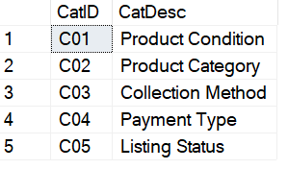

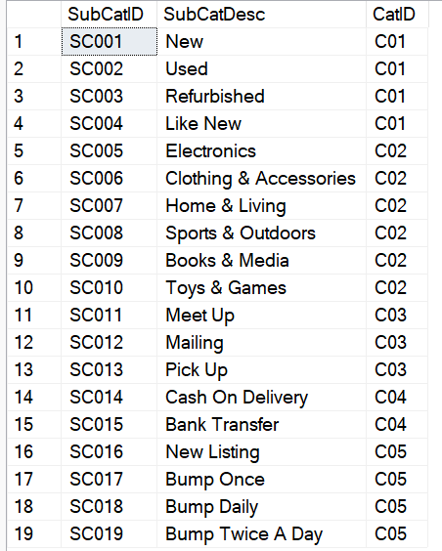
Subcategory Table

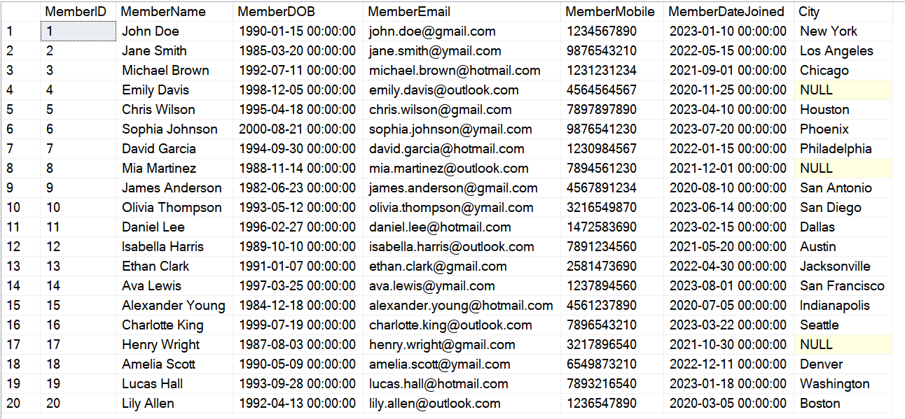
Member Table
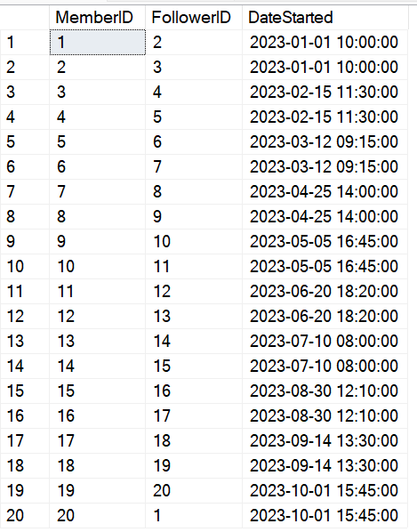
Follower Table

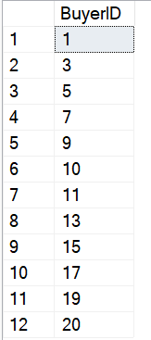
Buyer Table

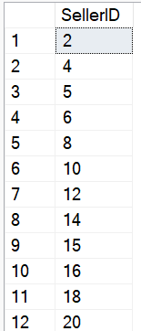
Seller Table

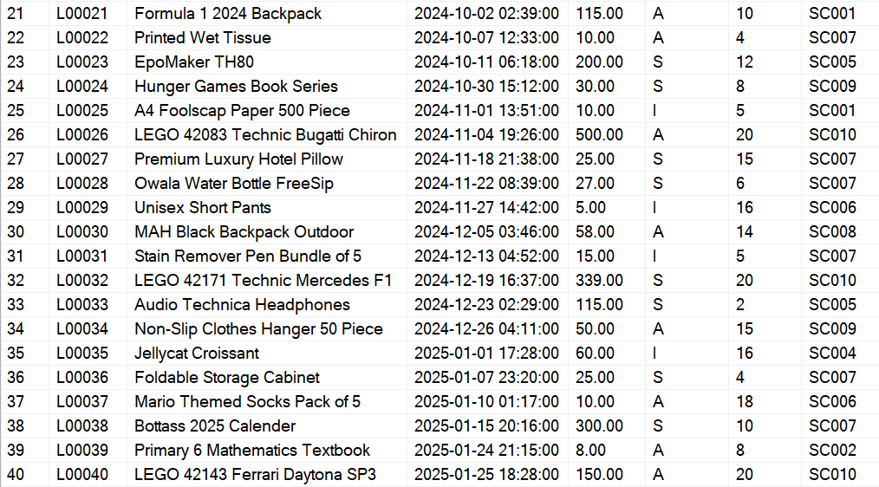
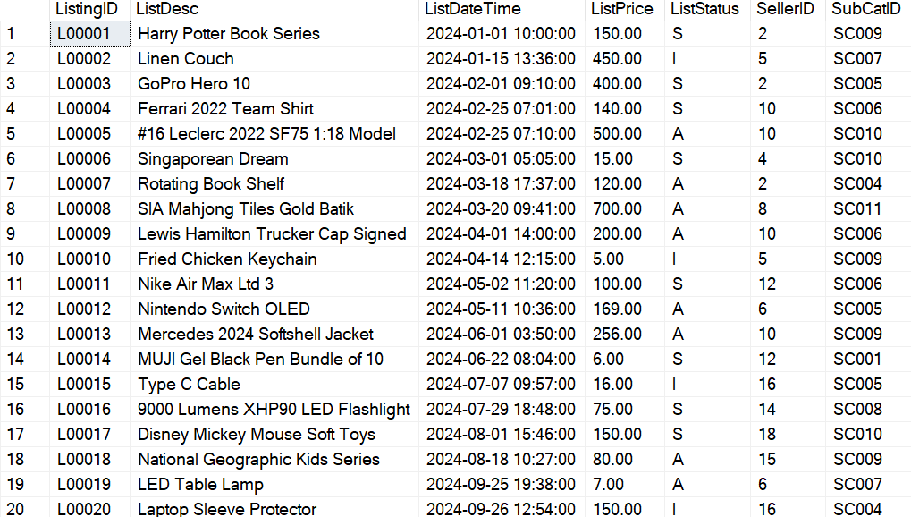
Listing Table

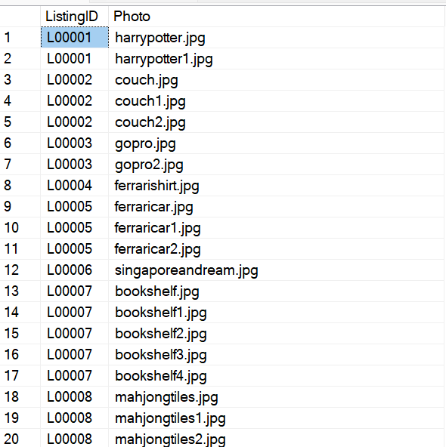
ListingPhoto Table

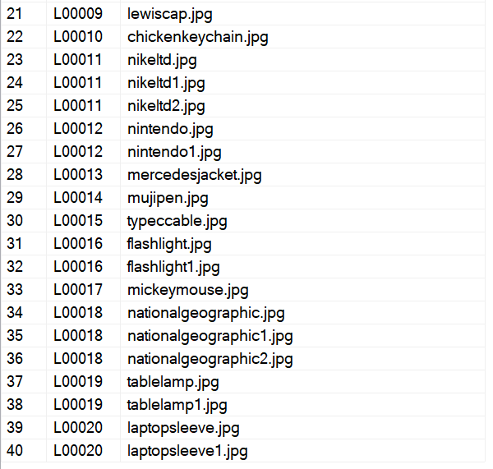

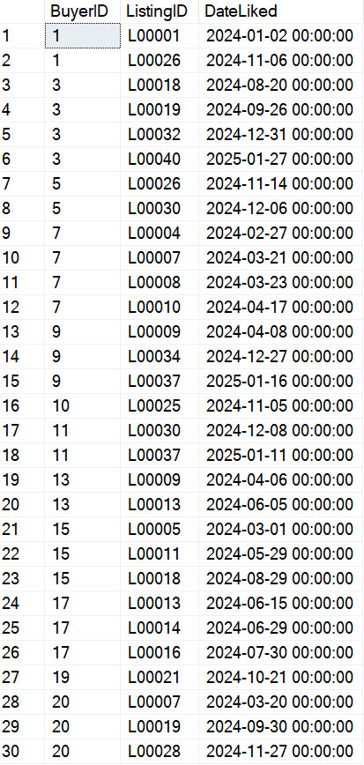
Likes Table

Offer Table
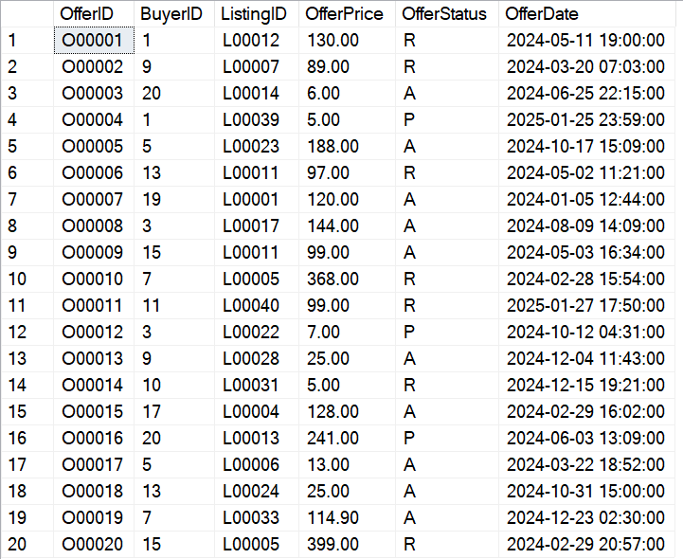

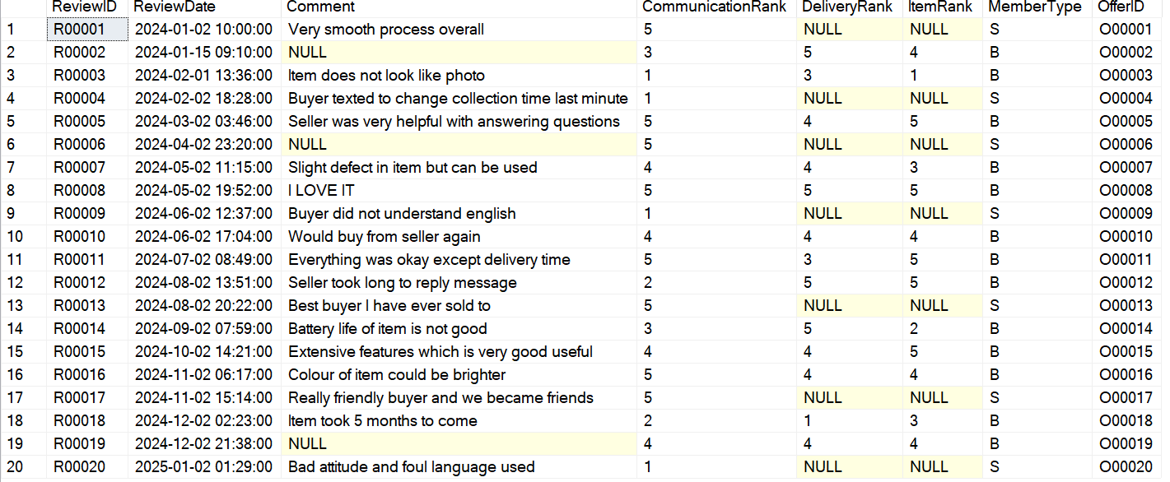
Review Table

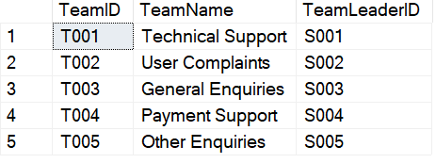
Team Table

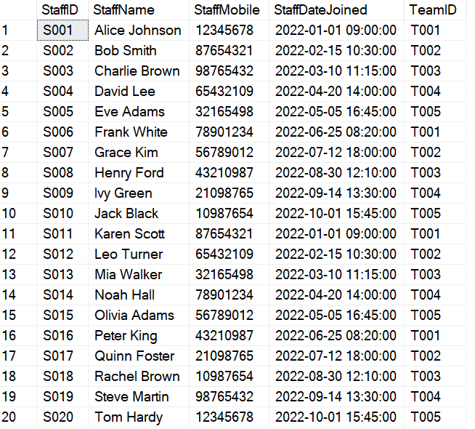
Staff Table

Award Table
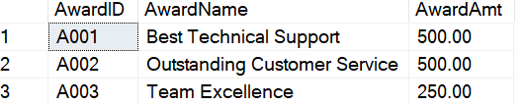

Win Table
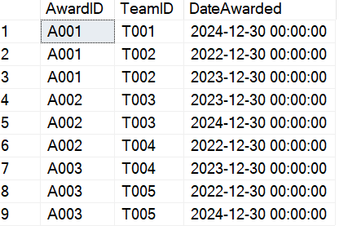

FeedbkCat Table
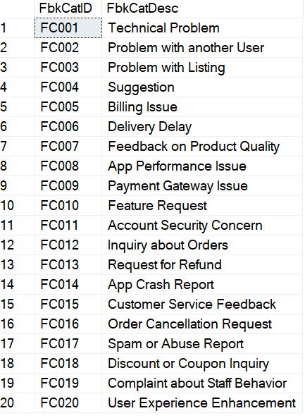

Feedback Table
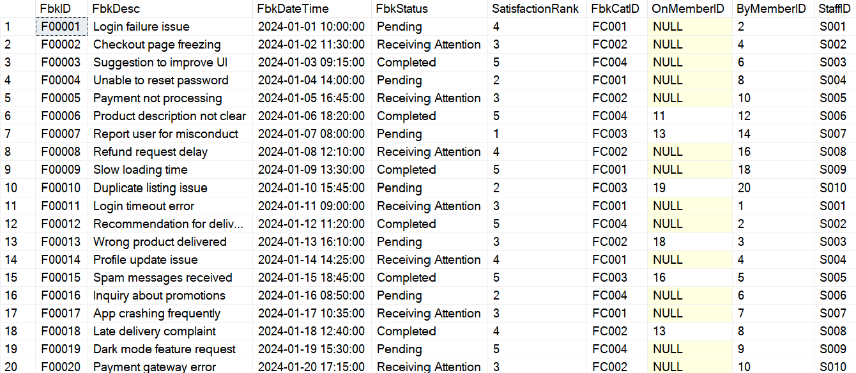

Bump Table
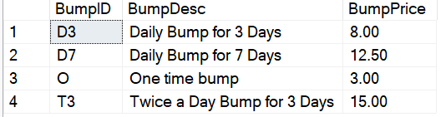

BumpOrder Table
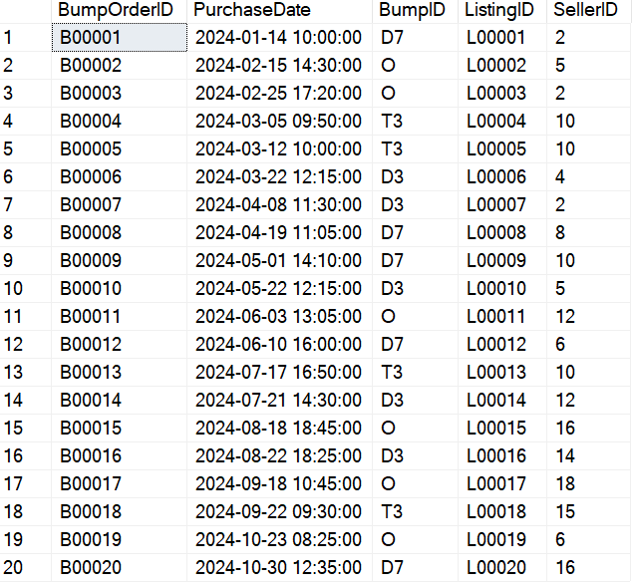
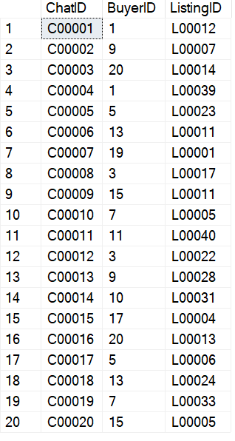
Chat Table

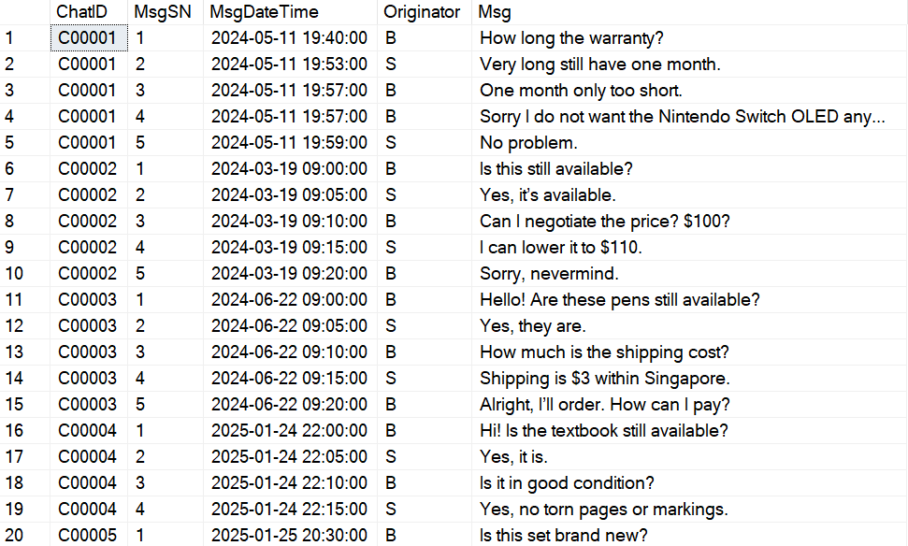
ChatMsg Table
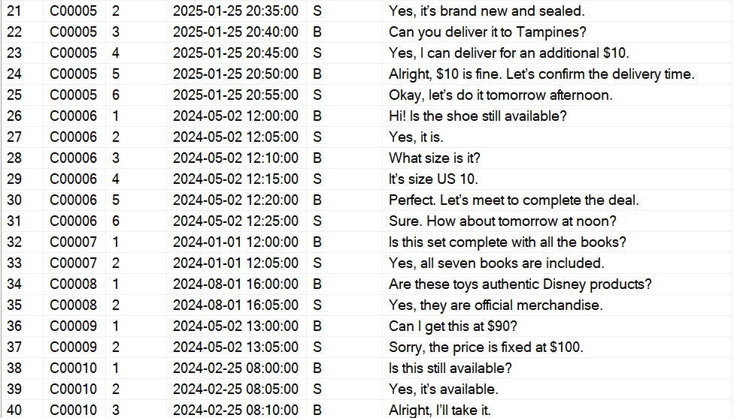
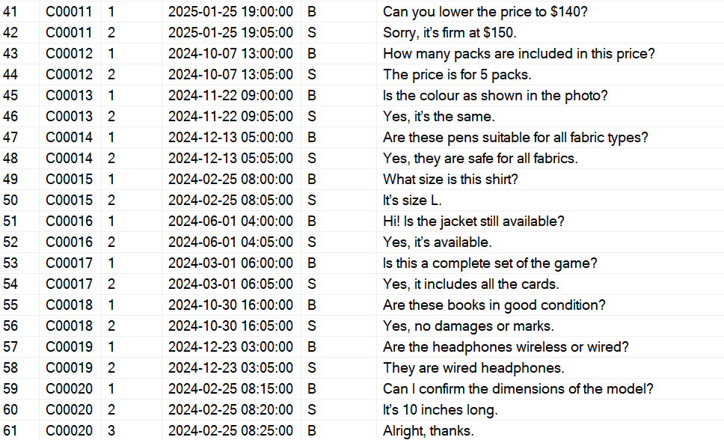

Individual Queries

Ashley
- Show the most popular listing categories according to the total amount of likes they have by descending order. Display the results as shown below:
Category TotalLikes

SELECT
SC.SubCatDesc AS Category,
COUNT(LI.ListingID) AS TotalLikes
FROM
SubCategory SC
INNER JOIN
Listing L ON SC.SubCatID = L.SubCatID
INNER JOIN
Likes LI ON L.ListingID = LI.ListingID
GROUP BY
SC.SubCatDesc
ORDER BY
TotalLikes DESC;

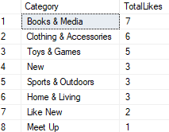

- Find the average satisfaction rank by descending order for each feedback category. Display the results as shown below:
FeedbackCategory AvgSatisfactionRank

SELECT
FC.FbkCatDesc AS FeedbackCategory,
AVG(F.SatisfactionRank) AS AverageSatisfactionRank
FROM
FeedbkCat FC
INNER JOIN
Feedback F ON FC.FbkCatID = F.FbkCatID
GROUP BY
FC.FbkCatDesc
ORDER BY
AverageSatisfactionRank DESC;

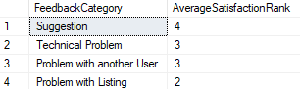

- Show users, whether they are a buyer or seller, who gave low review ratings (below 3) and show their reasonings by descending order of date. Display the results as shown below:
ReviewID MemeberID MemberName ReviewedAs ReviewReason

SELECT
R.ReviewID,
M.MemberID,
M.MemberName,
R.MemberType AS ReviewedAs,
R.Comment AS ReviewReason
FROM
Review R
INNER JOIN
Offer O ON R.OfferID = O.OfferID
INNER JOIN
Listing L ON O.ListingID = L.ListingID
INNER JOIN
Member M ON
(R.MemberType = 'S' AND M.MemberID = L.SellerID) OR
(R.MemberType = 'B' AND M.MemberID = O.BuyerID)
WHERE
(R.CommunicationRank < 3 OR R.DeliveryRank < 3 OR R.ItemRank < 3)
ORDER BY
R.ReviewDate DESC;

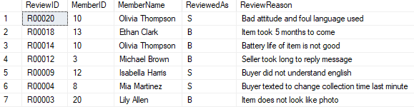

Rachel

- Find the top performing staff who have received the highest average satisfaction rank for their feedback. Display the results as shown below:
StaffID StaffName TeamID AvgSatisfaction

SELECT
S.StaffID,
S.StaffName,
S.TeamID,
AVG(F.SatisfactionRank) AS AvgSatisfaction
FROM
Feedback F
INNER JOIN
Staff S ON F.StaffID = S.StaffID
GROUP BY
S.StaffID, S.StaffName, S.TeamID
ORDER BY
AvgSatisfaction DESC,
S.StaffName ASC;

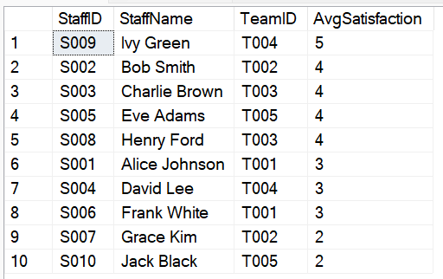

- Find the most active sellers which created the most number of listings in 2024. Display the results as shown below:
SellerID SellerName TotalListings

SELECT
L.SellerID AS SellerID,
M.MemberName AS SellerName,
COUNT(L.ListingID) AS TotalListings
FROM
Listing L
INNER JOIN
Member M ON L.SellerID = M.MemberID
WHERE
YEAR(L.ListDateTime) = 2024
GROUP BY
L.SellerID, M.MemberName
ORDER BY
TotalListings DESC,
SellerName ASC;

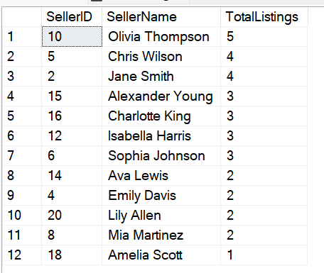

- Find the peak chat activity hour, arranging it from the highest to lowest chat activity. Display the results as shown below:
ChatHour TotalMessages

SELECT
DATEPART(HOUR, CM.MsgDateTime) AS ChatHour,
COUNT(CM.MsgSN) AS TotalMessages
FROM
ChatMsg CM
GROUP BY
DATEPART(HOUR, CM.MsgDateTime)
ORDER BY
TotalMessages DESC;

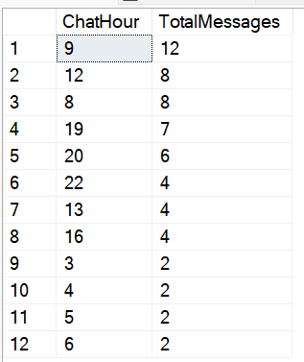

Dylan

- What is the total revenue generated from bumps by Product Category, shown in descending order?

SELECT
SC.SubCatID AS 'SubCategory ID',
C.CatDesc AS 'Category',
SC.SubCatDesc AS 'SubCategory Description',
SUM(B.BumpPrice) AS 'Total Revenue'
FROM
SubCategory SC
INNER JOIN
Category C ON C.CatID = SC.CatID
INNER JOIN
Listing L ON SC.SubCatID = L.SubCatID
INNER JOIN
BumpOrder BO ON L.ListingID = BO.ListingID
INNER JOIN
Bump B ON B.BumpID = BO.BumpID
WHERE
C.CatDesc = 'Product Category'
GROUP BY
SC.SubCatID, SC.SubCatDesc,C.CatDesc
Order BY
SUM(B.BumpPrice) desc;

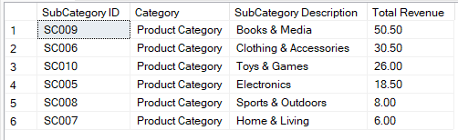

- Identify how much each bump type is purchased, in descending order.
SELECT
B.BumpDesc AS 'Bump Type',
COUNT(BO.BumpID) AS 'Purchase Count'
FROM
BumpOrder BO
INNER JOIN
Bump B ON B.BumpID = BO.BumpID
GROUP BY
B.BumpDesc
ORDER BY
COUNT(BO.BumpID) DESC

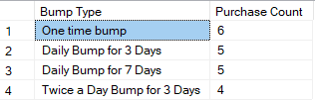

- List all the members who have purchased a bump, as well as the amount they have spent.

SELECT
L.SellerID AS Seller_ID,
COUNT(BO.BumpID) AS 'Total Bump Orders',
SUM(B.BumpPrice) AS 'Total Spent'
FROM
Listing L
INNER JOIN
BumpOrder BO ON L.ListingID = BO.ListingID
INNER JOIN
Bump B ON B.BumpID = BO.BumpID
GROUP BY
L.SellerID

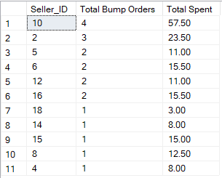

Jin Rui

- Find the total number of feedback entries for each feedback category description, in descending order. Display the results as shown below:
FbkCatDesc TotalFeedbacks

SELECT
FC.FbkCatDesc,
COUNT(F.FbkID) AS TotalFeedbacks
FROM Feedback F
INNER JOIN FeedbkCat FC ON F.FbkCatID = FC.FbkCatID
GROUP BY FC.FbkCatDesc
ORDER BY TotalFeedbacks DESC;

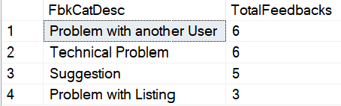

- Retrieve categories that have more than 3 subcategories assigned to them, in descending order. Display the results as shown below:
CatID CatDesc SubCategoryCount

SELECT
C.CatID,
C.CatDesc,
COUNT(SC.SubCatID) AS SubCategoryCount
FROM Category C
INNER JOIN SubCategory SC ON C.CatID = SC.CatID
GROUP BY C.CatID, C.CatDesc
HAVING COUNT(SC.SubCatID) > 3
ORDER BY SubCategoryCount DESC;

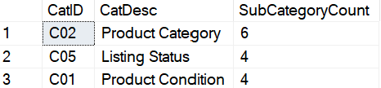

- Retrieve listing IDs, listing descriptions, and seller names, but only for listings that have received at least two offers. Display the results as shown below:
ListingID ListDesc SellerID SellerName

SELECT
L.ListingID,
L.ListDesc,
S.SellerID,
M.MemberName AS SellerName
FROM Listing L
INNER JOIN Seller S ON L.SellerID = S.SellerID
INNER JOIN Member M ON S.SellerID = M.MemberID
WHERE L.ListingID IN (
SELECT ListingID
FROM Offer
GROUP BY ListingID
HAVING COUNT(OfferID) >= 2
);

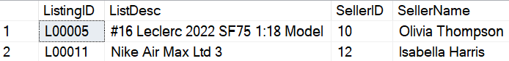

Tiffany

- Determine the number of active, inactive, sold listings and offers for sellerid 10. Display the results as shown below:
ActiveListings InactiveListings SoldListings TotalOffers

SELECT
L.SellerID,
(SELECT COUNT(*) FROM Listing L1 WHERE L1.ListStatus = 'A' AND L1.SellerID = L.SellerID) AS 'ActiveListings',
(SELECT COUNT(*) FROM Listing L2 WHERE L2.ListStatus = 'I' AND L2.SellerID = L.SellerID) AS 'InactiveListings',
(SELECT COUNT(*) FROM Listing L3 WHERE L3.ListStatus = 'S' AND L3.SellerID = L.SellerID) AS 'SoldListings',
COUNT(O.OfferID) AS TotalOffers
FROM
Listing L INNER JOIN Offer O
ON L.ListingID = O.ListingID
WHERE
L.SellerID = '00010'
GROUP BY
L.SellerID;

- Find the total revenue generated by each seller from accepted offers and order according to highest revenue. Display the results as shown below:
SellerID SellerName TotalRevenue

SELECT
S.SellerID,
M.MemberName AS 'SellerName',
SUM(O.OfferPrice) AS 'TotalRevenue'
FROM
Seller S
INNER JOIN Listing L ON S.SellerID = L.SellerID
INNER JOIN Offer O ON L.ListingID = O.ListingID
INNER JOIN Member M ON S.SellerID = M.MemberID
WHERE
O.OfferStatus = 'A'
GROUP BY
S.SellerID, M.MemberName
ORDER BY
SUM(O.OfferPrice) Desc;

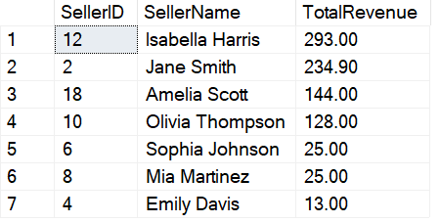

- List the average satisfaction rank for members who have given the most feedback. Display the results as shown below:
MemberID MemberName FeedbackCount AverageSatisfactionRank

SELECT
M.MemberID,
M.MemberName,
COUNT(F.FbkID) AS 'FeedbackCount',
(SELECT ROUND(AVG(SatisfactionRank), 2) FROM Feedback F WHERE F.ByMemberID = M.MemberID) AS 'AverageSatisfactionRank'
FROM
Member M INNER JOIN Feedback F ON M.MemberID = F.ByMemberID
GROUP BY
M.MemberID, M.MemberName
HAVING
COUNT(F.FbkID) = (SELECT MAX(FeedbackCount)
FROM (SELECT ByMemberID, COUNT(FbkID) AS FeedbackCount FROM Feedback GROUP BY ByMemberID)
AS FeedbackCounts);

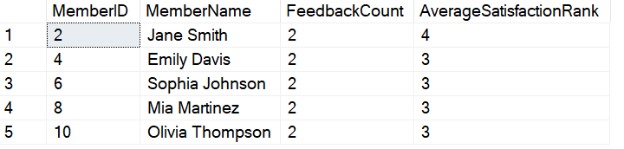

Individual Contributions

Ashley – Buyer, Likes, Offer, Chat, ChatMsg
Rachel – Member, Team, Award, Win
Dylan – Category, SubCategory, Bumporder, Bump
Jin Rui – Follower, Staff, Feedback, Feedbkcat
Tiffany – Seller, Listing, ListingPhoto, Review

